Task:

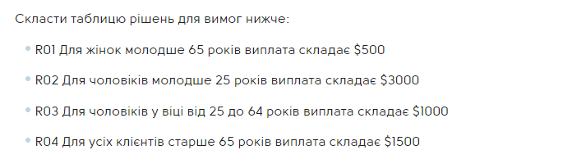

|  | TESTCASE1 | TESTCASE2 | TESTCASE3 | TESTCASE4 | TESTCASE5 | TESTCASE6 |
| --- | --- | --- | --- | --- | --- | --- |
| Conditions: |  |  |  |  |  |  |
| Man | F | F | F | T | T | T |
| Woman | T | T | T | F | F | F |
| older 65 | F | F | T | F | F | T |
| younger 25 | F | T | F | T | F | F |
| between 25 to 64 | T | F | F | F | T | F |
| Actions: |  |  |  |  |  |  |
| Result (payment) | 500$ | 500$ | 1500$ | 3000$ | 1000$ | 1500$ |